THE PARTICK & THORNWOOD IDEAS FUND 2026-27


APPLICATION GUIDANCE
Updated April 2026

Thank you for your interest in applying to the Partick and Thornwood Ideas Fund!
This guide will help you understand more about the fund, how to make an application, and the process of awarding grants. It is important that you understand the funding criteria, your commitments, and the community voting process.




- WHAT IS PARTICPATORY BUDGETING?
Participatory Budgeting (PB) is a democratic way for people to have a direct say on how public money is spent. PB gives people the opportunity to identify and discuss what matters to them in their communities and to vote on their priorities.
The fund gives individuals and groups an opportunity to apply for grants to realise their ideas which will deliver a positive change for local people in the community. Everyone living or working in the Partick and Thornwood area will have the opportunity to vote and decide which projects are funded.
- FUNDING CRITERIA
We are accepting applications for projects or activities that will deliver a positive change for the Partick and Thornwood communities. These projects must be openly accessible to any resident e.g. free, except where certain criteria are relevant to the project.
Projects that have previously received funds must return a completed feedback report before they can reapply.
NEW**: From October 2024, applicants can only be awarded one successful grant award each year (1st April to 31st March). Those who successfully voted to receive funding in Round 15, are not eligible to apply until the next round. This ensures there is a fair distribution of funds to groups and individuals across Partick and Thornwood.
- WHAT CAN FUNDS BE USED FOR?
Funds must be used to benefit the community of Partick and/or Thornwood. Funds can be used for a wide range of things from training, buying equipment, starting you own group, group running costs, activities, running events or trips. Funds cannot be used for alcohol, tobacco, or anything for your own personal needs. Ideas that have a religious or political aim cannot apply. You must spend all funds on your idea.
For examples of what’s been funded previously take a look at our voting results at: https://www.annexecommunities.org.uk/project-budgeting/
- WHO CAN APPLY?
Applications can be made by individuals or a representative of a group or project. Groups can be constituted or un-constituted. We know that some projects based outside the area can deliver activities locally, so these projects can still apply if they are able to provide a local sponsor, but the application must include evidence of how the project will be specifically targeted to Partick and Thornwood residents. Anyone under the age of 18 can apply but must also provide an adult sponsor. We know that great ideas can come from anyone and any age. Anyone under 18 will need an adult sponsor. An adult sponsor must be over 18 and be willing to support you to develop your idea and make it happen, ensure funds received are spent in line with the application. An adult sponsor can be a parent, teacher or youth worker etc.

- HOW MUCH CAN I APPLY FOR?
Individuals can apply for a grant of £150 up to £500
Groups or projects can apply for a grant of £150 up to £1000
- KEY DATES ROUND 16 (2026-27)
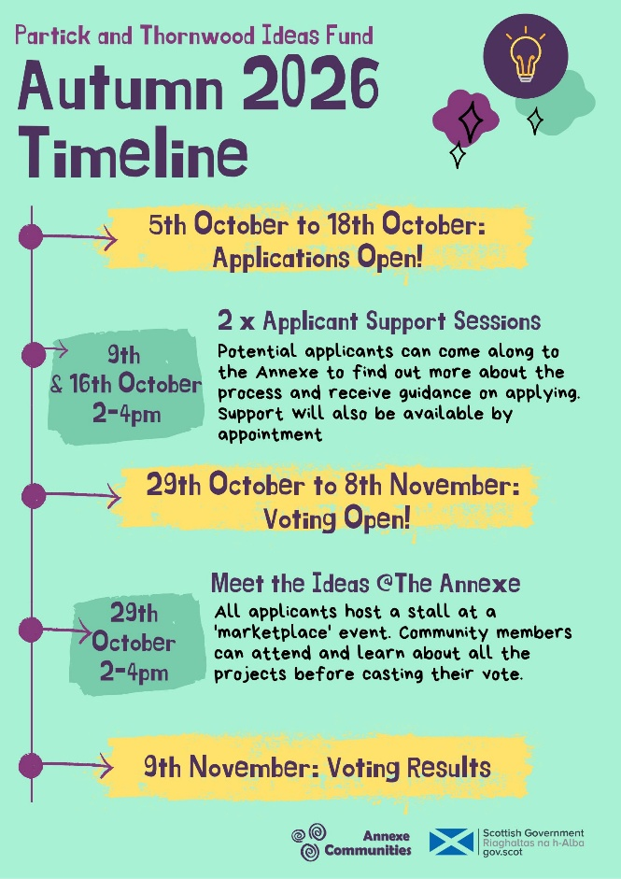
- APPLICATION SUPPORT
Application support sessions are available to help with your application. Steering group members will help to explain how your idea is eligible and we would recommend all new applicants to attend. Dates above.
- RETURNING YOUR APPLICATION
Please return your application form via email – pb@annexecommunities.org.uk
Or via post/by hand to Partick & Thornwood Ideas Fund, Annexe Healthy Living Centre, 9a Stewartville Street, Glasgow, G11 5PE
Note – applications must be sent in original word format or on paper – photographs or images of application forms are not acceptable.
Or if your group is based outside the Partick and Thornwood area – but will involve and benefit Partick and Thornwood residents – you will need sponsor who lives in the area.
- PAYMENT OF GRANT
You must have a bank account to receive your funds if you are successful in your application. If you or the group, you are representing does not have a bank account you must nominate an individual to receive the funds.

- DELIVERING PROJECT
For this round of funding projects must be delivered and completed by 30th September 2026.
REPORTING AND SPENDING
If successful in securing funds, you will need to provide receipts to show evidence of what you spent the funds on. We will also ask for you to report back about your idea with evidence of its impact, which can include photographs, anecdotes from people benefiting from your idea, and the difference your idea made.
- COMMUNITY VOTING
The community voting allows people in the local area to have the opportunity to vote and decide which ideas are funded.
Who can vote?
Anyone can vote who lives or works in the Partick and Thornwood area.
How do people vote?
- There will be 2 voting methods, online and over the phone
- Everyone eligible to vote must make 3 equal votes.
- All 3 votes must be for 3 different ideas. This will make the process fairer and encourage people to consider other applicants and find out what the community has to offer.
Online voting
Voters will click on a link through social media platforms or Annexe website (https://www.annexecommunities.org.uk/vote). They will then be shown a list and brief description of all applicants’ ideas which they can click on for more detail. They will select 3 ideas from the list to vote for who they would like to receive the funds.
Phone voting
Voters will be able to call 0141 212 3981 during voting period and state their 3 different votes on the ideas they would like to receive funds. Idea titles with brief descriptions will also be publicised via local organisations e.g. on public notice boards. This will raise public awareness and explain the voting procedure.
Once voting ends, votes from both events will be totalled. The ideas with the most votes will receive funding, continuing down the list until the funds available are spent.
Good luck with your idea!

Question Guidance
The following guidance aims to help you complete the application and understand what our panel will look for in your application.
Statement: Please tick if your proposal will benefit the local area.
Question 1 – Who is applying (you MUST supply either an email or a telephone number)
Please write the full name of the lead applicant for the project (must be a single individual).
Please tell us the name of your group or organisation (if applicable).
Please write the full contact address.
Please write a contact telephone number
Please write a contact email address.
Please tick the correct box indicating whether you are applying as an individual, a constituted group, a non-constituted group (A constituted group has a formal constitution and a committee with set roles, e.g. a chair) or charity.
Question 2: What are you applying for?
Please give your project a name (this will be listed when people cast their votes).
Please tick whether this is a new project.
Please summarise your idea in 30 words or less. These 30 words will be used to publicise your idea for voting.
Question 3: Summarise your idea
Please summarise your idea in 30 words or less. This summary will be included in an information pack to help local people decide how to vote at the event. Please include why you feel your proposal is important and why it should be supported by the community.
Question 4: Full outline of your idea?
Please explain in detail what your idea is, this will help the steering group to understand what you plan to do and determine if the application is eligible to be put to the public vote.
Write a description of your idea. Include things like a start date and an end date. Tell us how your idea allows local people to participate in society / community life. What will the added benefit be? For example:
“Our community needs more space for people to spend time outside and our young people need to be more active and learn about their environment……. Our youth group wants to learn about gardening and develop a community garden on the waste ground next to our building which is full of litter and dog fouling. These improvements will allow older people to walk around and enjoy this area. We will start the group in May and continue till last week in September.”

Question 5: Total funds required?
Please write the total funds required for your project (this is the amount you are requesting from the Ideas Fund).
Please list out a full breakdown of how the funds would be spent on the project. E.g. what equipment you would buy or other expenses.
Question 6: Information of local involvement?
Explain how local people have been involved in developing the idea/project?
How will it benefit the Partick and Thornwood community?
Sponsor
Only complete this if the lead applicant is 16 or under or the applicant group is not based in the Partick and Thornwood geographical area.
Fill out the contact details. A phone number or email MUST be provided.
The adult sponsor must sign.
Checklist: tick to confirm that you are aware of the key dates of the project, and you understand your obligations
Sign: Lead applicant signs here

